NAME : H.Bharath krishnan ROLL NO.:241901017

EXERCISE 1
BASIC LINUX AND WINDOWS COMMAND
AIM:
To introduce and practice essential networking commands in Linux and Windows operating systems for configuring, monitoring, and troubleshooting network connections. This exercise aims to build fundamental skills required for diagnosing and managing network environments using command-line tools.
LINUX COMMAND:
- ls – list directory
Synopsis: ls [option]… [File]…
Description: Display files and directories in the current working directory. By default, entries are sorted alphabetically.
- touch – change file / create empty file
Synopsis: touch [option]… [File]…
Description: Shows detailed information for each file, including permissions, owner, size, and time.
- cat – concatenate and display file contents
Synopsis: cat [option]… [file]
Description: Prints the contents of one or more files to standard output. Useful for viewing or combining files.
- ls -l – long listing format
Synopsis: ls -l
Description: Shows detailed information for each file, including permissions, owner, and size.
- chmod – change file permissions
Synopsis: chmod [option]… mode file
Description: Changes the permission bits of files. You can use numeric or symbolic notation.
- mkdir – make directories
Synopsis: mkdir [option]… Directory
Description: Creates a new directory. Use -p to create parent directories as needed.
- ls -a – list all files including hidden
Synopsis: ls -a
Description: Lists all files, including hidden ones, inside the open directory.
- nano – text editor
Synopsis: nano [file]
Description: Launches a user-friendly text editor in the terminal to edit files.
- rm – remove files
Synopsis: rm [option]… File…
Description: Deletes files or directories. Use -r for recursive removal, -f to force without prompt.
- rmdir – remove empty directories
Synopsis: rmdir (directory)
Description: Deletes a directory only if it is empty.
- ps -e – list all running processes
Synopsis: ps -e
Description: Shows currently running processes in the system.
- grep – search for text patterns inside files or output
Synopsis: grep "word" file.txt
Description: Filters process list to show only those matching the given name or keyword.
- echo – display text, variables or messages
Synopsis: echo [string]
Description: Prints the given text to the terminal. Often used in scripting.
- top – real-time process viewer
Synopsis: top
Description: Displays a dynamic list of running processes along with CPU and memory usage.
- free – display memory message
Synopsis: free [option]
Description: Shows the amount of free and used memory in the system. Use -h for human-readable output.
- vmstat – report system performance
Synopsis: vmstat [delay] [count]
Description: Displays memory, CPU, I/O, system performance statistics.
- traceroute – tracks the path
Synopsis: traceroute [IP address/hostname]
Description: Identifies the path taken by packets to reach a network host.
- ping – test network connectivity
Synopsis: ping [destination]
Description: Sends ICMP echo requests to a network host to check if it's reachable.
- ifconfig – view network interfaces
Synopsis: ifconfig
Description: Displays or configures network interface parameters (now largely replaced by ip addr).
- vi – text editor
Synopsis: vi [file]
Description: Opens the vi editor to create or modify files; offers powerful editing features.
- cd – change directory
Synopsis: cd [directory]
Description: Changes the current working directory.
- pwd – print working directory
Synopsis: pwd
Description: Shows current location.
OUTPUT:
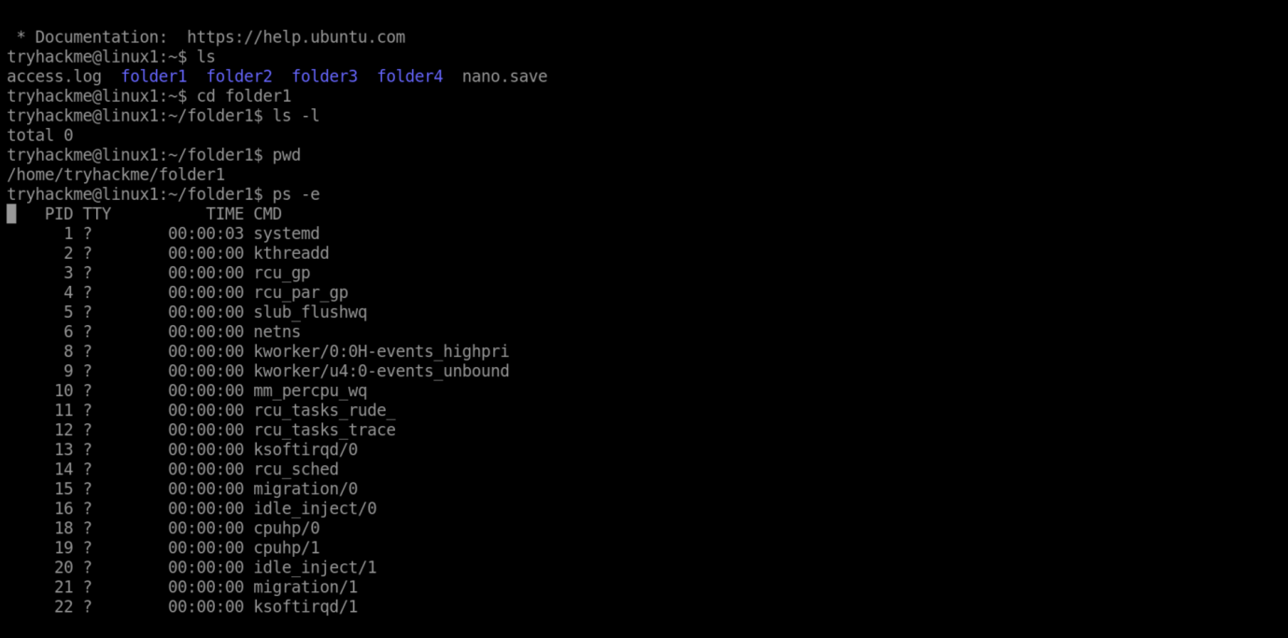

WINDOWS COMMAND:
- dir - Equivalent of ls
Synopsis: dir [path] [[options]]
Description: List all files and directories.
- cd - Change directory
Synopsis: cd [path]
Description: Changes the current working directory.
- cls - Clear screen
Synopsis: cls
Description: Removes all text.
- echo - Prints
Synopsis: echo [message]
Description: Displays messages, useful in batch scripts.
- dir -a (like ls -a)
Synopsis: dir -a [path]
Description: Lists files and directories.
- mkdir - make directory
Synopsis: mkdir [drive:] [path] foldername
Description: Create a new directory in a specified path.
- del - delete file (remdir)
Synopsis: del file.txt
Description: Delete files or directories from the file system.
- tasklist - display all currently running process
Synopsis: tasklist [options]
Description: Lists process name, PID (Process ID), session name/ID, and memory usage.
- find - search for a specific string of text within files
Synopsis: find "string" [filename]
Description: Looks for the given "string" inside the specified file.
- systeminfo - detailed system configuration information
Synopsis: systeminfo
Description: Often used for system audits and troubleshooting.
- typeperf - display or log performance counter data
Synopsis: typeperf [counter...] [options]
Description: Can display output in the console or save it to a log file (CSV, TSV, binary).
- tracert - Trace the path packets take to reach
Synopsis: tracert [options] <hostname or IP>
Description: Displays each router packets travel through until reaching the destination.
- ping - network connectivity
Synopsis: ping [option] <hostname or IP>
Description: Displays packet loss, response time, and TTL (Time to Live).
- ipconfig - displays and manages IP address
Synopsis: ipconfig [options]
Description: Shows current network adapter configuration.

OUTPUT:
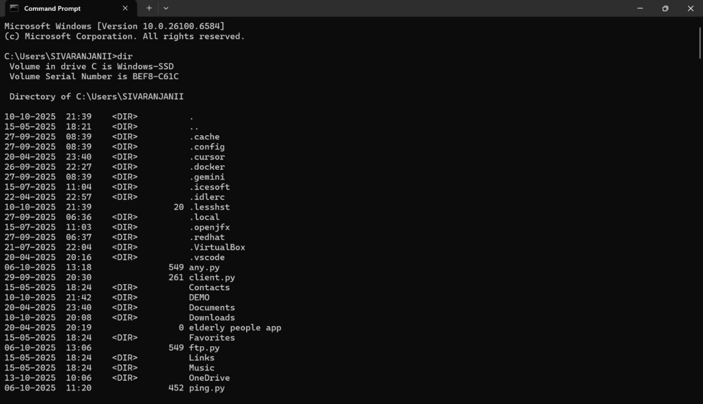
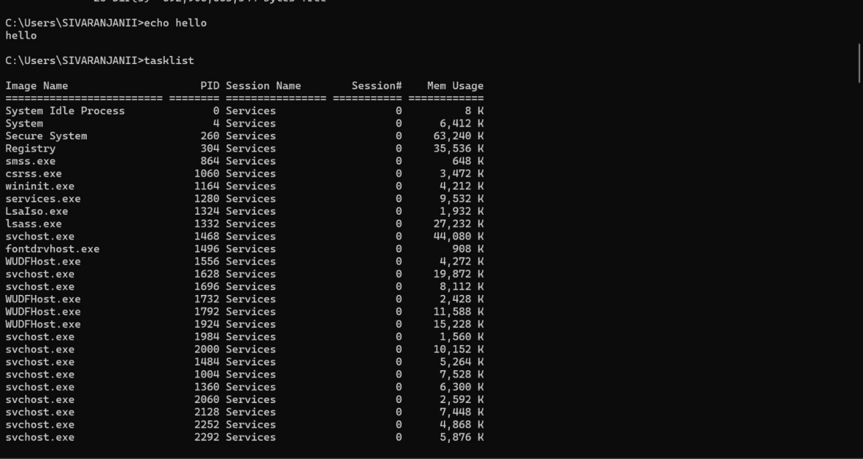
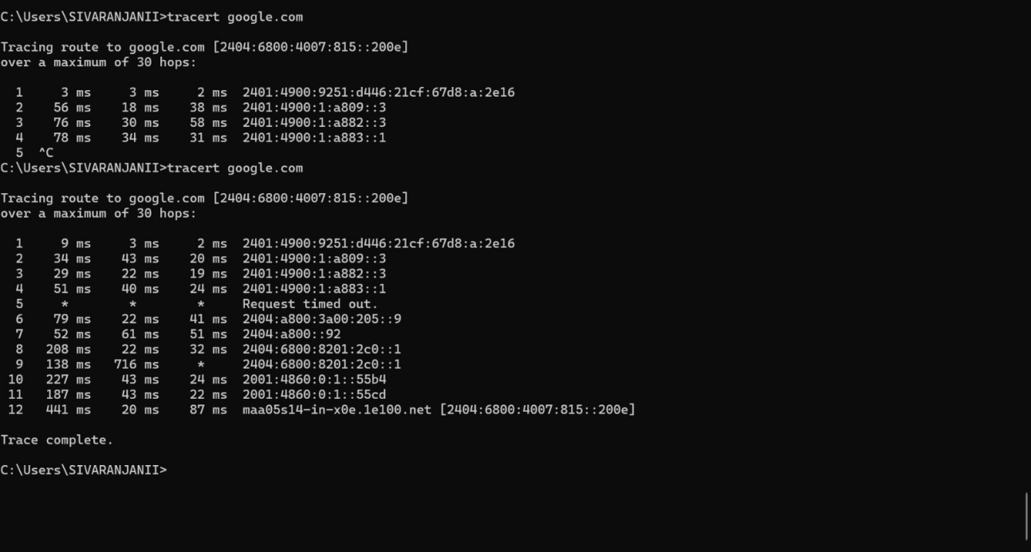

RESULT:
All listed basic Linux and Windows networking commands were executed and tested successfully in their respective terminal environments. The commands produced the expected outputs, allowing for efficient directory navigation, file management, system monitoring, and network troubleshooting. This experiment verified the practical functioning and usefulness of each command for real-world administrative and technical tasks.

